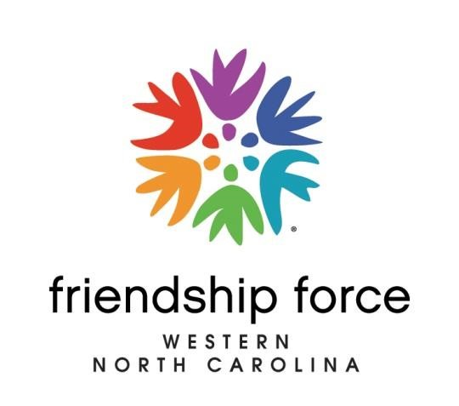
Membership Application / Renewal
Send to: Treasurer, FFWNC, P.O. Box 384, Hendersonville, NC 28793
(Separate Application per person)

PLEASE CHECK ONE:

□ New Membership w/badge $57 per person $_____________

□ Renewal Membership $45 per person $_____________

□ Associate (if you are a member of another FFI club and pay
that club’s full dues) $15 per person $_____________

Name: ______________________________ Date of Application __________________________
Address: __________________________________________________________________________
Phone: _____________________________ Cell Phone: __________________________________
Email: ___________________________________________________________________________
Year joined FFWNC __________ Birthday _________________ Anniversary _________________
How did you hear about Friendship Force of Western North Carolina? _________________________
__________________________________________________________________________________
Friendship Force is a volunteer organization. Our success depends upon member participation.
AREAS YOU ARE WILLING TO SERVE:
____ Board of Directors or Officer
____ Committee Chair (i.e, Hospitality, Membership, Publicity, Newsletter)
____ Journey Coordinator
____ Hosting – home, dinner, day *
*Please visit the FFWNC website at: https://ffwesternnc.org/being-a-friendship-force-host/
to learn about home, dinner and day hosting opportunities.
(Rev. 01/17/24)

